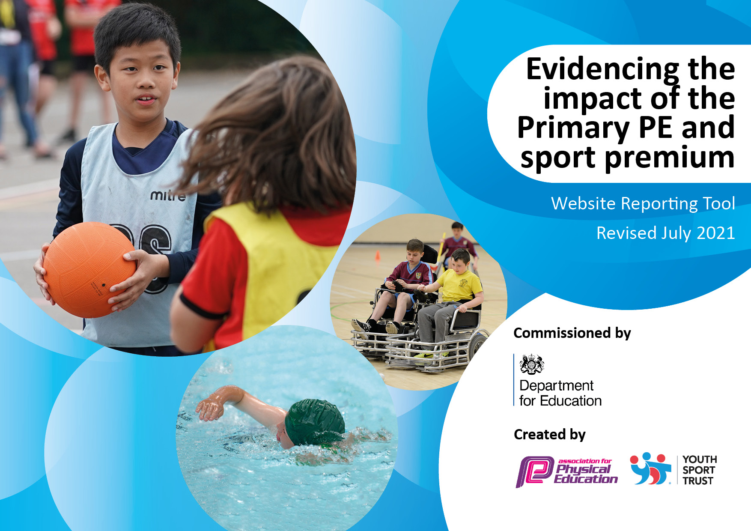
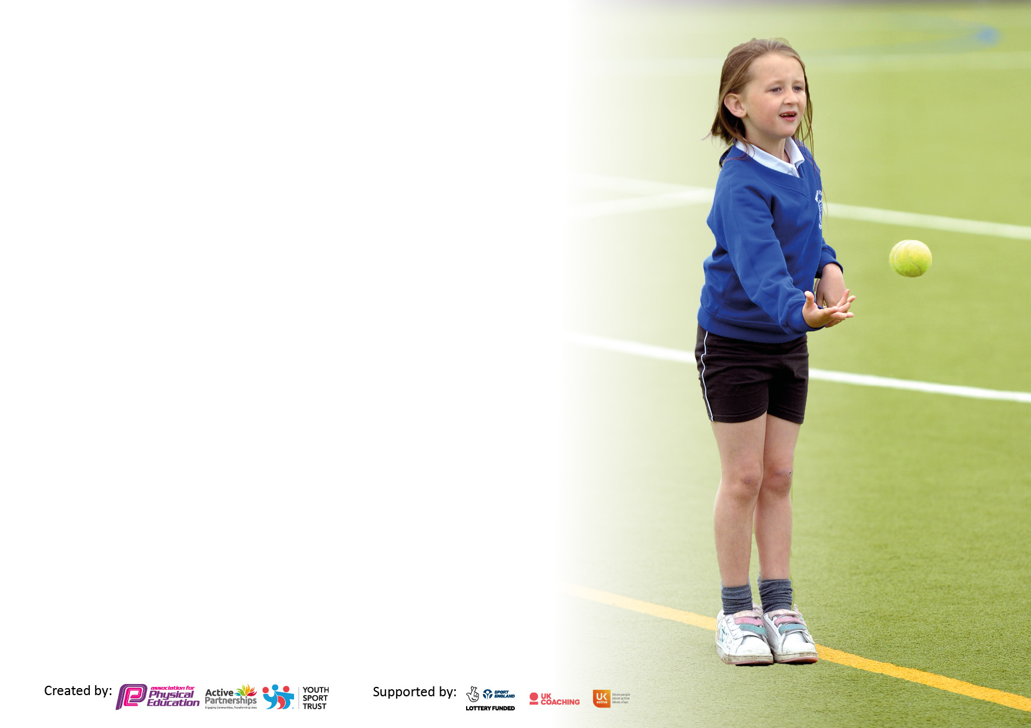

It is important that your grant is used effectively and based on school need. The Education Inspection Framework makes clear there will be a focus on ‘whether leaders and those responsible for governors all understand their respective roles and perform these in a way that enhances the effectiveness of the school’.

Under the Quality of Education Ofsted inspectors consider:
Intent - Curriculum design, coverage and appropriateness
Implementation - Curriculum delivery, Teaching (pedagogy) and Assessment
Impact - Attainment and progress

To assist schools with common transferable language this template has been developed to utilise the same three headings which should make your plans easily transferable between working documents.

Schools must use the funding to make additional and sustainable improvements to the quality of Physical Education, School Sport and Physical Activity (PESSPA) they offer. This means that you should use the Primary PE and sport premium to:

Develop or add to the PESSPA activities that your school already offer
Build capacity and capability within the school to ensure that improvements made now will benefit pupils joining the school in future years
The Primary PE and sport premium should not be used to fund capital spend projects; the school’s budget should fund these.

Please visit gov.uk for the revised DfE guidance including the 5 key indicators across which schools should demonstrate an improvement. This document will help you to review your provision and to report yours pend. DfE encourages schools to use this template as an effective way of meeting the reporting requirements of the Primary PE and sport premium.

We recommend you start by reflecting on the impact of current provision and reviewing the previous spend.

We recommend regularly updating the table and publishing it on your website throughout the year. This evidences your ongoing self-evaluation of how you are using the funding to secure maximum, sustainable impact. To see an example of how to complete the table please click HERE.


Details with regard to funding
Please complete the table below.

Total amount carried over from 2024/25 | £0
Total amount allocated for 2025/26 | £16,810
How much (if any) do you intend to carry over from this total fund into 2024/25? | £0
Total amount allocated for 2025/65 | £16,810
Total amount of funding for 2025/26. To be spent and reported on by 31st July 2026. | £16,810
Swimming Data
Please report on your Swimming Data below.

Meeting national curriculum requirements for swimming and water safety.  N.B. Complete this section to your best ability. For example you might have practised safe self-rescue techniques on dry land which you can then transfer to the pool when school swimming restarts.  Due to exceptional circumstances priority should be given to ensuring that pupils can perform safe self rescue even if they do not fully meet the first two requirements of the NC programme of study | 90%
What percentage of your current Year 6 cohort swim competently, confidently and proficiently over a distance of at least 25 metres?  N.B. Even though your pupils may swim in another year please report on their attainment on leaving primary school at the end of the summer term 2025.  Please see note above | 90%
What percentage of your current Year 6 cohort use a range of strokes effectively [for example, front crawl, backstroke and breaststroke]? | 90%
What percentage of your current Year 6 cohort perform safe self-rescue in different water-based situations? | 90%
Schools can choose to use the Primary PE and sport premium to provide additional provision for swimming but this must be for activity over and above the national curriculum requirements. Have you used it in this way? | No

Action Plan and Budget Tracking
Capture your intended annual spend against the 5 key indicators. Clarify the success criteria and evidence of impact that you intend to measure to evaluate for pupils today and for the future.

Academic Year: 2025/26 | Total fund allocated: £16,810 | Date Updated: September 2025
Key indicator 1: The engagement of all pupils in regular physical activity – Chief Medical Officers guidelines recommend that primary school pupils undertake at least 30 minutes of physical activity a day in school |  |  |  | Percentage of total allocation:
 |  |  |  | £9,582 = 57%
Intent | Implementation |  | Impact
Your school focus should be clear what you want the pupils to know and be able to do and about what they need to learn and to consolidate through practice: | Make sure your actions to achieve are linked to your intentions: | Funding allocated: | Evidence of impact: what do pupils now know and what can they now do? What has changed: | Sustainability and suggested next steps:
To ensure all pupils access high-quality PE lessons.  To ensure provision for PE and quality of resources is effective to maximise pupil engagement.  To ensure EYFS pupils make strong progress in physical development.  To increase opportunities for pupils to engage in physical activity during break times and lunch times. | Classes to work with Rossendale Sports Coach for one hour per week. Sports Coach focusses on developing games skills, e.g. football, netball, basketball and cricket (CPD for teachers and TAs).  Sports markings to be laid on the school field for football, rounders and athletics running track for sports day.  EYFS sport / physical development equipment to be audited and to replenish equipment.  Audit and replenish school sports equipment. | £5500  £582  £1800  £1700 | Children will have clearly marked playing areas to ensure ball games at lunchtime and during PE lessons are safe. Safe spaces will be created on the playground away from the sports playing surfaces.  Children will access high-quality resources to support their learning and engagement in PE lessons.  ECT teachers feel more confident in delivering PE and Sport activities. The quality of provision for PE is good, and pupils enjoy PE lessons in school.  Pupils in EYFS achieve their Early Learning Goal for physical development. Pupils including girls enjoy physical activity. | Offer lunch clubs and afterschool clubs to engage pupils in new sports.  Monitor and regularly audit the equipment to ensure high quality. Replace older worn equipment with new equipment.  Continue to work with Rossendale coaches to offer additional clubs afterschool in order to promote school sport.  Continue to offer a wide range of sporting opportunities across the school calendar year and increase participation further.

Key indicator 2: The profile of PESSPA being raised across the school as a tool for whole school improvement |  |  |  | Percentage of total allocation:
 |  |  |  | £3,870 = 23%
Intent | Implementation |  | Impact
Your school focus should be clear what you want the pupils to know and be able to do and about what they need to learn and to consolidate through practice: | Make sure your actions to achieve are linked to your intentions: | Funding allocated | Evidence of impact: what do pupils now know and what can they now do? What has changed? | Sustainability and suggested next steps:
To offer more lunchtime and after school club experiences.  Pupils’ behaviour to improve in English and maths lessons as a result of increased physical activity.  Pupils to improve in their academic performance as a result of increased physical activity.  Pupils to have improved physical and mental health as a result of increased physical activity.  Pupils to have improved sharing and team working skills as a result of accessing more team games.  Children to access a minimum of two hours PE per week. | To provide lunch time sports clubs across the year so that pupils can participate in extracurricular activities.  Children to participate in additional extra-curricular clubs after school.  To identify new experiences for children to access such as judo and archery.  To target disadvantaged pupils to participate in extra-curricular activities and new experiences. | £1970  £1900 | More pupils are now accessing a wider range of activities before and after school.  The range of clubs has increased such as girls’ football, cricket, table tennis, Thai kickboxing, Yoga etc, which means pupil participation is increasing.  More pupil premium children are now engaging in afterschool clubs and sport, as we have seen an increase compared to the previous year. | Continue to prioritise PE and school sport in school and continue to offer a wide range of clubs during lunch and afterschool.  Employ additional lunchtime staff to deliver sporting clubs.  Continue to monitor and promote Pupil Premium pupil take up of clubs and sports.  Track and monitor and share report with governors.  Complete a pupil voice survey to see what further opportunities pupils would like to engage with such as any other clubs for the next academic year.

Key indicator 3: Increased confidence, knowledge and skills of all staff in teaching PE and sport |  |  |  | Percentage of total allocation:
 |  |  |  | £830 = 5%
Intent | Implementation |  | Impact
Your school focus should be clear what you want the pupils to know and be able to do and about what they need to learn and to consolidate through practice: | Make sure your actions to achieve are linked to your intentions: | Funding  allocated: | Evidence of impact: what do  pupils now know and what can they now do? What has changed? | Sustainability and suggested next steps:
To provide staff with a new, coherent and well sequenced curriculum for the delivery of PE.  To provide staff with CPD on how to deliver the new PE curriculum effectively. | Pay subscription for Lancashire PE curriculum.  Provide CPD opportunities. | £830 | The curriculum has been purchased from Lancashire School Sport and children have access to high-quality lessons with a clear sequence and progression of skills. | Provide CPD to ensure staff delivers lessons effectively.  Teachers to join Sports Coach PE lessons for CPD opportunities.  Support and train new PE subject leader next term so that they continue to make strong progress.

Key indicator 4: Broader experience of a range of sports and activities offered to all pupils |  |  |  | Percentage of total allocation:
 |  |  |  | £1,850 = 11%
Intent | Implementation |  | Impact
Your school focus should be clear what you want the pupils to know and be able to do and about what they need to learn and to consolidate through practice: | Make sure your actions to  achieve are linked to your  intentions: | Funding  allocated: | Evidence of impact: what do  pupils now know and what can they now do? What has  changed? | Sustainability and suggested next steps:
To offer a wide range of clubs and experiences to engage pupils in sport.  To provide opportunities for pupils to access new sports / experiences.  To provide opportunities for pupils to watch professional sport. | Year 5/6 children to attend Residential Activity Centre.  Identify talented children to join alternative local sports clubs / activities | £1000  £850 | All upper Key Stage pupils including pupil premium pupils had the opportunity to watch live professional sports.  Year 5/6 to attend residential in July. They will take part in water sports and a range a physical activity. | Continue to provide opportunities for pupils to watch live professional sport.  Provide opportunities in school to participate in these new sports as an afterschool clubs next academic year.

Key indicator 5: Increased participation in competitive sport |  |  |  | Percentage of total allocation:
 |  |  |  | £678 = 4%
Intent | Implementation |  | Impact
Your school focus should be clear what you want the pupils to know and be able to do and about what they need to learn and to consolidate through practice: | Make sure your actions to  achieve are linked to your  intentions: | Funding  allocated: | Evidence of impact: what do  pupils now know and what can they now do? What has changed? | Sustainability and suggested next steps:
To provide increased opportunities for pupils to take part in competitive sport. | To provide transport to competitive sporting events- e.g. local cluster Trust Athletics / Football | £678 | Pupils will experience competitive sport. Pupils will have the opportunity to discover their talents.  Pupils will be identified and exit routes to clubs will be provided. | Continue to enter sporting events to ensure pupils enjoy competition.  Maintain Gold Sports Mark.

Signed off by
Head Teacher: | Paul Cowburn
Date: | 30/09/2026
Subject Leader: | Paul Cowburn
Date: | 30/09/2026
Governor: | Graham Donnan
Date:

